
Mercy Corps Headquarters

FINAL REPORT
Revision 1
LEED® NC 2.2 Energy Analysis

January 16, 2009

Disclaimer
The results of the energy analysis presented in this report cannot be construed to have absolute, predictive accuracy, representing the actual energy use of the building or its individual systems. All reasonable efforts have been taken to ensure the accuracy of the energy model inputs, including verifying that actual details correspond to the building as it is currently designed. The primary benefit of energy modeling is for comparison of alternative design options to determine their relative energy savings potential.

There a number of factors that will cause the actual energy use of the building to diverge from the projected energy use of the model. Among these are: differences in building design relative to the building modeled; abnormal weather conditions; variations in schedules for equipment, systems, and occupancy; inconsistencies in the application of controls and operations strategies compared to those used in the model; the level of direct loads; and changes in connected loads and electricity and gas rates. In addition, the model results do not necessarily take into account all the energy uses of a facility or building site that would show up as loads on the utility meters.

Nevertheless, refinements of the energy model to reconcile all these differences, when these adjustments are made by a capable energy engineer, can yield model results that are more consistent with actual energy use.

Table of Contents
Executive Summary 1
Summary and Results 4
Results 6
eQUEST runs with DEC and ECB results 7
Energy Savings Strategies 8
Occupancies 8
Utilities 8
Electricity 8
Natural Gas 8
Building envelope 9
Above-Grade Walls 10
Below-Grade Walls 10
Roof 10
Slab on grade floor 10
Windows 11
Infiltration 11
Lighting - Interior 12
Lighting—exterior 12
Plug loads 12
Elevators 13
Mechanical and plumbing systems 13
Forced AC systems 13
Domestic hot water 15
Exceptional Calculations 16
Exceptional calculation 1: Variable refrigerant flow energy recovery 16
Appendix A—Energy Optimization 17
Appendix B-1.1—BEPS report, run for the Mercy Corps design model 21
Appendix B-1.2—BEPU report, run for the Mercy Corps design model 22
Appendix B-1.3—ES-D report, run for the MERCY CORPS design model 23
Appendix B-2.2—BEPU reports, runs for the MERCY CORPS baseline model 28
Appendix B-2.3—ES-D reports, runs for the MERCY CORPS baseline model 32

Executive Summary
The new Mercy Corps Headquarters is a renovation/addition to the historic Packer Scott Building located in Downtown Portland, Oregon. The building is a half existing renovation and half new construction addition, totaling approximately 80,000 square-feet, consisting primarily of office space. The DOE2 based software eQUEST was used to simulate the energy performance of the building. A 3-D model representation can be seen in Figure 1 below.

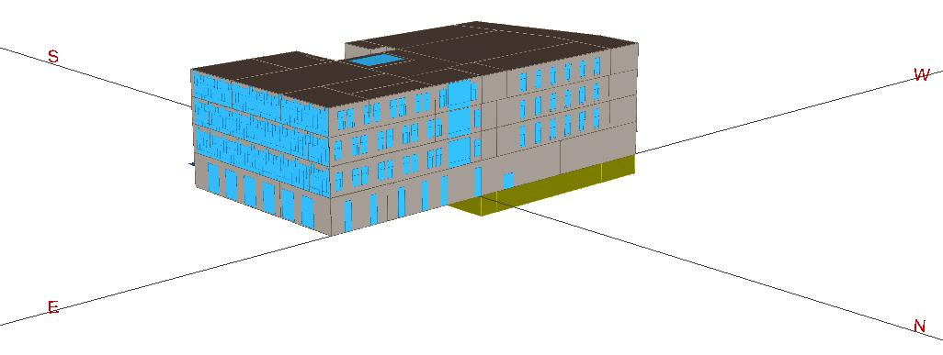
Figure 1 – 3-D computer model of the new Mercy Corps headquarters

The project team is striving for a LEED® Platinum rating, so energy performance is a high priority since there are 10 available points under Energy & Atmosphere, Credit 1 – Optimize Energy Performance. The standard used for energy performance analysis is the Performance Rating Method (PRM) as defined in Appendix G of ASHRAE 90.1-2004.
The design incorporated many energy efficiency measures (EEMs) that were analyzed throughout the design process. These EEMs include, but are not limited to:
- Variable Refrigerant Flow HVAC system
- 100% OSA make up air system
- Daylighting
- Improved envelope insulation
- Improved windows
- 79 kW photovoltaic array
Since the Mercy Corps Headquarters is a partial existing building renovation and partial new construction, the New Construction and Existing Building point thresholds for EAc1 are averaged to give the new point thresholds for this specific project. Each point threshold is adjusted to 3.6 percentage points less than the New Construction thresholds (e.g. the first point starts at 6.9% instead of 10.5%).
The Energy Use Intensity (EUI) for the baseline and design building is 82.2 and 43.2, respectively. Figure 2 illustrates the annual energy use, in MBtus per year, of the different end uses, such as interior lighting, space heating and cooling, and miscellaneous equipment, for the baseline and design buildings.

Figure 2 – Baseline vs. design energy end uses

The annual energy costs for the baseline and design buildings are $1.29 and $0.83 per square-foot per year, respectively. Figure 3 below illustrates the differences in utility costs of gas and electricity for the baseline and design buildings.

Figure 3 – Annual gas and electricity costs

Using LEED and ASHRAE 90.1 rules, the energy cost savings relative to the budget baseline, without renewables, is calculated to be $37,624 per year or 35.56%. With the addition of a 68.6 kW PV array, the building saves an additional $5,044, increasing the total energy cost savings to $42,160 or 39.85%. Table 1, below, shows how the savings are calculated, separating the Energy Cost Budget (ECB) and Design Energy Cost (DEC) results according to their gas and electricity use.

Table 1 – Energy optimization by fuel type

Summary and Results
The new Mercy Corps Headquarters is a renovation/addition to the historic Packer Scott Building located in Downtown Portland, Oregon. The existing portion, approximately 42,000 square-feet, makes up the western half of the building, with four above grade floors and one below grade floor. The addition, approximately 40,000 square-feet, makes up the eastern portion of the building, with only four above grade floors and no below grade. The 3-D eQUEST model graphics show four different views of the complex in Figures 4A, 4B, 4C, and 4D.

Figure 4A - View from the NE

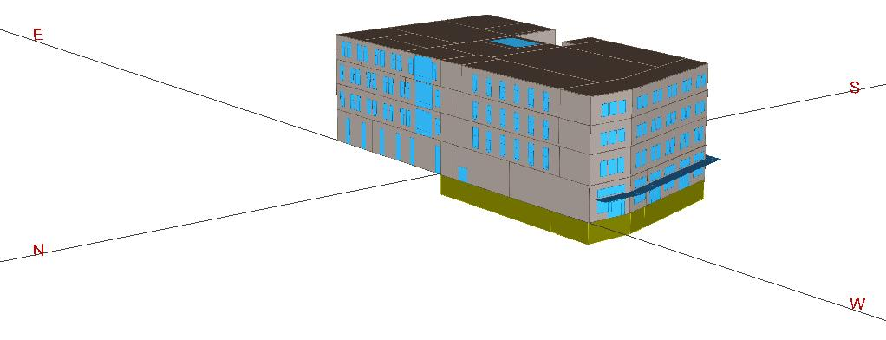

Figure 4B - View from the NW

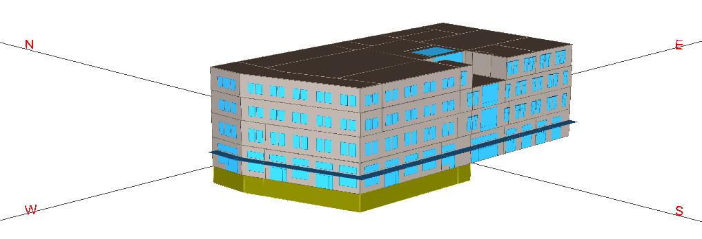

Figure 4C - View from the SW

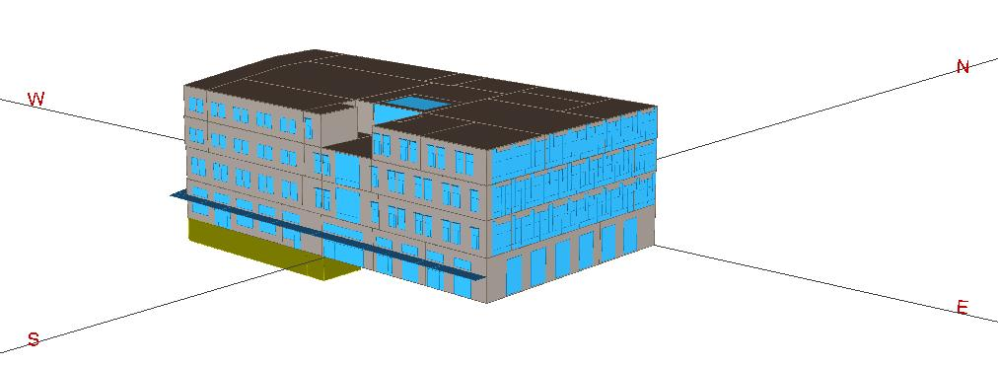

Figure 4D - View from the SE

Results
This report presents the energy savings resulting from an analysis of the differences between the proposed design and the budget baseline developed using ASHRAE 90.1-2004 following the Performance Rating Method (PRM) as defined in Appendix G.
Since the Mercy Corps Headquarters is a partial existing building renovation and partial new construction, the New Construction and Existing Building point thresholds for EAc1 are averaged to give the new point thresholds for this specific project. The new point thresholds can be seen in Table 2 below.

Table 2 – Adjusted EAc1 Point Thresholds

Using LEED and ASHRAE 90.1 rules, the energy cost savings relative to the budget baseline, without renewables, is calculated to be $37,624 per year or 35.56%. With the addition of a 68.6 kW PV array, the building saves an additional $5,044, increasing the total energy cost savings to $42,160 or 39.85%. Table 3, on the following page, shows how the savings are calculated, separating the Energy Cost Budget (ECB) and Design Energy Cost (DEC) results according to their gas and electricity use.
Based on these new point thresholds, the project is eligible for up to ten (10) LEED points for the Optimize Energy Performance Credit under the LEED NC 2.2 table.
Table 3 – Energy Optimization by fuel type

eQUEST runs with DEC and ECB results
Full tabulation of all key modeling results may be found in Appendix A.

Energy Savings Strategies
The new Mercy Corps Headquarters is located in the mild climate of Portland, Oregon. The majority of the space is used for offices for 150-190 staff member, while a portion of the building on the first floor is dedicated to a learning center providing public education related to the challenges Mercy Corps is addressing throughout the works, a gallery, and a small rentable retail space. The side is bordered to the North by the Burnside Bridge, to the West by First Avenue and the MAX line, to the South by Ankeny Plaza, and to the Easy by Naito Parkway. The overall topography of the site is flat.
Numerous energy savings strategies have been incorporated in the project, including, but not limited to, variable-refrigerant flow fan coil units, increased wall and roof insulation, high efficiency windows, a photovoltaic array, a green roof, a high efficient lighting design. Details on the energy savings strategies can be seen below.

Occupancies
Occupancy is expected to be typical office space hours of operation, with employees arriving around 7:00AM and leaving around 5:00PM, Monday through Friday. The retail portion of the building is open seven days a week.
Other schedules, such as lighting and HVAC, are built around these parameters. Schedules are the same in the proposed design and budget baseline models.

Utilities

Electricity
Portland General Electric – Rate 83. Large nonresidential customers whose demand does not exceed 1,000 kW. Monthly charges include a basic charge, demand charge, energy charge, and system usage charge. Average rate for the proposed design is $0.070 per kWh.

Natural Gas
NW Natural Gas – Schedule 31. Nonresidential service. Monthly charges include a basic charge and energy charge. Average rate for the proposed design is $2.10 per therm.

NOTE
The average utility rates may appear high compared to the incremental costs per kWh for electricity or per therm for gas. However, the average rate is the equivalent of the total energy cost divided by the total energy used, in kWh or in therms.
For example, the average gas rate of $2.10 cents per therm takes into account much more than incremental cost of a therm. There may be time-of-use, peak, seasonal, and demand charges, as well as tiered rates and account base charges.

Building envelope
Table 4 summarizes all the key inputs for the baseline and as-designed models. Details are described in the sections that follow.
Table 4 – Summary of model inputs
Model Input Parameter | Proposed Design Input | Baseline Design Input 0o
Exterior Wall Construction | R-10 rigid polystyrene. Average U = 0.080 | Addition: R-13 batt insulation within frame. Average U = 0.124  Existing: Uninsulated brick wall. Average  U = 0.99
Roof Construction | Average 6-inches of rigid polystyrene. Average U = 0.031 | Continuous rigid insulation above deck. Average U = 0.063
Below-Grade Wall Construction | Uninsulated concrete. Overall capacitance of 1.140 | Same as proposed design
Floor/Slab Construction | Uninsulated concrete | Same as proposed design.
Window-to-wall ratio | 35.4% overall | Same as proposed design.
Fenestration Type | Double pane, low-e glass.  Cardinal, Solarban 60, Solarban 70, Fritted. | Double pane, low-e glass.
Fenestration U-factor  (overall) | Fixed glazing: Assembly U-0.41  Operable glazing: Assembly U-0.47  (ASHARE 31.8 of 2005 Fundamentals) | Assembly U-0.57
Fenestration SHGC (SC) | Cardinal: 0.41 (0.47)  Solarban 70 Starphire: 0.27 (0.31)  Solarban 60 Clear: 0.38 (0.44)  Translucent: 0.23 (0.26) | 0.25 (Appendix G specifies non-north values for ALL glazings)
Fenestration Visual Light Transmittance | Cardinal: 0.80  Solarban 70 Starphire: 0.63  Solarban 60 Clear: 0.70  Translucent: 0.42 | Same as proposed design. There is no daylighting in the baseline, so VLT is irrelevant.
Shading Devices | Large shades on first floor, south and east facades.  Small shades on addition south façade. | No shades.
Interior Lighting Power Density | 0.91 W/sf | 1.0 W/sf (Office Building Area Method)
Daylighting Controls and other lighting control credits | Interior office daylighting dimming sensors. | Same as proposed design.
Exterior Lighting Power (kW) | 4,884 Watts | 1,580 Watts
Receptacle Equipment Power Density | 1.25 W/sf in conditioned spaces. | 1.25 W/sf (to meet minimum 25% of total energy costs).
Primary HVAC System Type | City Multi Variable Refrigerant Flow with 100% OSA make up air units providing ventilation air. | System 4 – Packaged VAV with DX cooling and hydronic reheat. One system per floor.
Fan Supply Volume | Make up air unit: ~26,500 cfm  Fan coils: ~56,500 cfm | 81,839 total cfm (20ºF ΔT heating and cooling based on space temperature and supply air temperature)
Fan Power | MAU: 0.0006284 kW/cfm  Fan coils: 0.0004532 kW/cfm | Supply: 0.0008734 kW/cfm  Return: 0.0002620 kW/cfm
Economizer Control | 100% make up air unit bypasses VRF fan coils when building load can be met with only ventilation air. There is no full economizer. | Fully modulating for all units up to 75ºF OAT.
Domestic Hot Water | 39,814 kWh per year for general office usage. ~3% of total building energy costs. | Same as proposed design.
Boiler efficiencies | Not modeled. | 80% efficient cast iron boiler.
Condenser unit efficiencies | VRF heating mode: 0.296 EIR  VRF cooling mode: 0.315 EIR | Heating: N/A  Cooling: 9.3 EER
Pumps | 0 kW | 19 kW/gpm
Heat recovery | Plate heat exchanger on the make-up air unit. 60% effective | N/A

Above-Grade Walls
Design. All above grade walls are constructed with two-inches of exterior rigid polystyrene insulation with an R-value of R-5 per inch. Exterior finishes vary from existing sandstone and brick with a majority of the addition being terracotta tile with small areas of spandrel panel. General layer sandwich is as follows, exterior to interior: <Exterior Finish>, Polystyrene 2in (IN35), Air Lay <3/4in Vert (AL11), GypBd 1/2in (GP01), 4in Metal Stud No Insulation, GypBd 1/2in (GP01). Calculated assembly U-factor of U-0.080.
Budget: The addtion exterior wall type is metal frame with R-13 between-stud insulation. The construction results in a code equivalent overall U-factor equal to 0.123.
The existing portion of the building is modeled as it was before the construction, as per Table G3.1 of Appendix G. Construction is face brick with assembly U-factor of U-0.99.

Below-Grade Walls
Design. The underground wall is uninsulated concrete, modeled with a capacitance of C-1.140.
Budget: Same as design.

Roof
Design. The design roof has an average of 6-inches of rigid polystyrene (R-5 per inch) entirely above deck. Roof layer sandwich is as follow, exterior to interior: Blt-Up Roof 3/8in (BR01), Polystyrene 6in R-5/in, Poured Concrete Slab, Interior Finish. Calculated assembly U-factor of U-0.031.
Budget. The addition roof is defined as R-15 continuous insulation entirely above deck to achieve a code equivalent overall U-factor of 0.063.

Slab on grade floor
Design. Modeled as a slab-on-grade floor, 6-in.thick, uninsulated concrete.
Budget. Same as design.

Windows
Design. The window-wall ratios for the north, east, south, and west façades were calculated to be 21.2%, 66.7%, 35.5%, and 29.1%, respectively. The total window-wall ratio for the building is 35.4%. With the percent glazing being lower than the 40% ratio allowed by ASHRAE 90.1-2004 Appendix G, the wall insulation has more of an impact on reducing the loads on the building, further increasing the value of the EEMs.
A wide variety of windows are to be installed throughout the building. All windows to be installed in the building are to have double-pane, ½” air space, ¼” glass, low-e, thermally broken glazing, with center-of-glass U-factors of 0.29. Assembly glazing U-factors are calculated using Table 4 on page 31.8 of the ASHRAE Fundamentals Handbook.
Window dimensions included the frames, but the frame width was left out of the model and instead the glass was modeled as the entire opening so the conductance would represent the overall assembly U-factor.
All existing windows consist of Cardinal glass with Wood frames, resulting in an assembly U-factor of 0.39 and 0.35 for the operable and fixed windows, respectively. To account for the film coefficient, the eQUEST Glass Conductance is 0.438 and 0.39 for the operable and fixed windows, respectively. The solar heat gain coefficient for all existing glazing is 0.41, or a 0.47 shading coefficient.
All clear glazing on the South and East facades of the addition is PPG Solarban 70 Starphire with aluminum thermally broken frames, resulting in an assembly U-factor of 0.47 and 0.41 for the operable and fixed windows, respectively. To account for the film coefficient, the eQUEST Glass Conductance is 0.548 and 0.464 for the operable and fixed windows, respectively. The solar heat gain coefficient for the Solarban 70 Starphire glazing is 0.27, or a 0.31 shading coefficient.
All clear glazing on the North facade of the addition is PPG Solarban 60 Clear with aluminum thermally broken frames, resulting in the same assembly U-factors and Glass Conductance as the PPG Solarban 70 Starphire. The solar heat gain coefficient for the Solarban 60 Clear glazing is 0.38, or a 0.44 shading coefficient.
All fritted, or frosted glazing on the addition has PPG Solarban 70 Starphire for the outer window pane, a ½” air space, an then two ¼” panes of glass sandwiched together with a frosted material in between. All have aluminum thermally broken frames, resulting in the same assembly U-factors and Glass Conductance as the PPG Solarban 70 Starphire. The translucent layer reduces the solar heat gain coefficient to 0.23, or a 0.264 shading coefficient.
Budget. The window-to-wall ratio for the conditioned office space falls between 30.1% and 40% range, requiring an overall assembly U-factor of 0.67 and 0.57 for operable and fixed windows, respectively, and solar heat gain coefficients of 0.39, or a 0.45 shading coefficient. Appendix G requires all baseline glazing solar heat gain coefficients to be “SHGC_{all}”. The eQUEST Glass Conductance for the baseline windows is 0.842 and 0.688 for operable and fixed windows, respectively.

Infiltration
Design. Infiltration is modeled to allow for between 0.2 and 0.4 air changes per hour (ACH) and fluctuates based on outdoor wind speeds.
Budget. Same as design.

Lighting - Interior
Design. Total connected lighting wattage of the building was calculated to be 75,000 Watts. At 82,474 square-feet, the overall lighting power density (LPD) is 0.91 W/sf. The LPD calculation was performed by the electrical engineers for the Oregon Energy Code compliance forms.
Daylighting sensors connected to automatic dimming ballasts are included in the perimeter office spaces.
Budget. The baseline building is modeled using the Building Area Method on Table 9.5.1 of ASHRAE 90.1-2004. The specified LPD for an office is 1.0 W/sf, or 82,474 Watts, resulting in a 9% reduction in lighting power over code.

Lighting—exterior
Design. There are a total of 1,100 connected watts for canopy lighting, as calculated by the electrical engineer for Oregon Energy Code compliance.
The parking lot has an area of approximately 5,120 square feet with four 120 Watt lamps illuminating the area, totaling 480 Watts for the entire parking lot.
There are 17 doors on the main level at an average width of three feet, totaling 51 feet of total linear door width. All doors are either illuminated by the canopy lighting or not illuminated.
Budget. According to the CIR dated April 25th, 2007, baseline exterior lighting power density is calculated according to Section 9.4.5 of ASHRAE 90.1-2004 and that credit can only be claimed for the “Tradable Surfaces” on Table 9.4.5. Canopy, parking lot, and exterior door lighting all fall under the tradable surfaces category.
Maximum canopy and parking lot lighting power is 1.25 and 0.15 W/sf, respectively. Main entries are allowed 30 W/linear foot of door width. See Table 5 below for baseline and design lighting power densities.
Table 5 – Summary of model inputs

There is no façade illumination.

Plug loads
Design. Same as the budget.
Budget. Plug loads were assumed to be an average of 1.25 W/ft² throughout the conditioned spaces of the building. This input was necessary to meet the requirement of 25% process energy costs of the baseline.

Elevators
Design. An elevator load is approximated at 3% of the total proposed kWh, based on ACEEE studies, totaling approximately 29,000 kWh per year, or about $2,000. The elevator energy use was included into the plug loads.
Budget. Same as design.

Mechanical and plumbing systems

Forced AC systems
Design. Primary building heating and cooling are provided by the Mitsubishi City Multi variable refrigerant flow (VRF) fan coil system. The system consists of an outdoor variable speed compressor heat pump condensing units mounted on the building roof. Two insulated refrigerant pipes connect this outdoor unit to a control terminal called a BC Controller. Refrigerant pipe and control wiring then connect multiple fan coil units to the BC Controller. The system is capable of providing heating or cooling to the space through the fan coils.
Each City Multi condensing unit can handle a maximum of approximately 20 tons, and cannot transfer heat between one another. Because of the size of the building, there are ten condensing units, two per floor, one for the basement, and an additional one for the retail portion of the first floor. Most of the condensing units serve both interior, exterior, north and south facing zones, providing the maximum heat transfer.
Horizontal fan coils are located over core area ceiling, within soffited areas, or in utility spaces. Unducted return air will mix with ventilation air ducted to each fan coil location. Ventilation for perimeter offices is provided through the mechanical system. Operable openings offer supplemental ventilation that also interlock with the space conditioning fan coils.
A central fresh air ventilation shaft and an exhaust shaft will be provided in the building core. The exhaust shaft will provide building exhaust for pressure relief, toilet exhaust, and other miscellaneous general exhaust. The fresh air ventilation air provided to each major space will be provided from a terminal VAV box controlled by CO₂ sensors in the space. The ventilation system will operate in parallel to the space conditioning system.
Both outside air and exhaust are provided by a factory built dedicated variable volume 100% outside ventilation air handler equipped with, air-to-air heat recovery, direct expansion cooling with condenser cooled by exhaust airstream and hot water heating coil.
Energy savings from this system comes from three major areas:
- No pumping energy. Very little energy is required to move the refrigerant through the piping. When a group of zones being served by a condensing unit are close to achieving a heating and cooling balance, the only energy required is a small compressor load to circulate the refrigerant through the pipes.
- Variable speed compressor. At the times between full heating or cooling and perfect heat balance, smaller amounts of heat need to be added or rejected. The variable speed compressor adds to the part load efficiency, adding to the energy performance of the system.
- Fan coils and OSA set up in parallel. By running the VRF fan coils and OSA in parallel, the fan coils can be turned off when the OSA can meet the loads of the building. Since Portland has a very mild climate with an annual average temperature of 55ºF, this can be met quite often.
- Heat exchange. Since the main condensing units serve at least one core space and multiple perimeter spaces, as well as north and south facing zones, heat can be transferred from zone to zone through the BC controller before additional heat is needed to be added or extracted by the outside condensing unit.
Fan power was calculated to be 0.0006284 kW/cfm for the make up air units and 0.000144 kW/cfm for the fan coils.

Modeling HVAC assumptions
Since eQUEST cannot explicitly model a variable refrigerant flow HVAC system, a system supported by eQUEST was modified to simulate the performance of the City Multi system. There are various methods in the energy modelling community for simulating a VRF system, and we have modified one of those methods to create a conservative approach of documenting the energy use.
The only other HVAC system that transfers heat from one zone to another in a similar manner is a water loop heat pump; however, there are three components in the water loop heat pump that are not apparent in a VRF system: condenser water loop, boilers, and cooling towers.
We instead chose to model the system as single zone split system heat pumps. A VRF system is essentially a group of air to air heat pumps that are allowed to exchange energy between one another before the condenser is required to extract or add energy back into the system.
Listed below is how each was modified to resemble the VRF:
- Single zone heat pumps. One conditioned zone was assigned per system. The system used was a PVVT (packaged variable air volume) system. Heating DX efficiency was given an EIR to resemble the COP of the condensing unit, approximately 0.296. The cooling DX efficiency was given an EIR of 0.315.
- Variable speed compressors. The PVVT system allows the use of a variable speed compressor as well as the same functionality as a packaged single zone unit.
- Energy recovery. A separate hand calculation was performed using hourly data to determine the amount of heat recovered from the VRF system. See the exceptional calculations section for more detail.
Although the compressors are variable speed, the VRF fan coils are constant volume. The minimum flow and fan ratio were set to 1.0 in eQUEST.
Budget. The building, being five floors, 80,000 square feet of conditioned space, and a mix of gas and electric heating, falls under System 5 as the baseline HVAC system, according to Table G3.1.1A.
According to the CIR dated June 19, 2007, the calculation from ASHARE 90.1-2007 Appendix G can be used to calculate the HVAC system fan power. Using the baseline design supply fan volume and the pressure drop adjustments for the make up air unit, the supply fan power was calculated to be 0.0008733 kW/cfm (75% of total fan power) and the return/exhaust fans were calculated to be 0.0002620 kW/cfm (25% of total fan power multiplied by 0.90 according to G3.1.2.8). See Table 6 for details.
Table 6 – Baseline fan power calculations

Domestic hot water
Design. A domestic hot water heater is modeled with an 80% efficient burner. Using a default schedule developed by eQUEST, the process load was increased until the energy use was equivalent to approximately 3% of the total building’s energy costs. This energy use correlates to the ACEEE and CEBECS database for domestic hot water in an office building.
Budget. Same as design.

Exceptional Calculations
The section describes all necessary descriptions and calculations for energy savings strategies that either required by the LEED rating system or cannot be directly modeled.

Exceptional calculation 1: Variable refrigerant flow energy recovery
The maximum capacity for a City Multi condensing unit is 20 tons and the Mercy Corps building contains 10 condensing units. For this reason, every space within the building cannot exchange energy with one another.
Hourly reports were created within eQUEST to output each zone’s electrical consumption for heating or cooling for a particular hour. In the hourly output Excel file, zones under the same condensing unit were grouped together. The heating energy and the cooling energy required for each hour under one condensing unit were added together. If heating and cooling energy were required in different zone, under the same VRF condenser, and in the same hour, the smaller of the two values was added as savings.
The spreadsheet included over one million pieces of data output from the hourly reports of eQUEST. A screenshot of a portion of the spreadsheet can be seen in Figure 5 on the following page.
The total kWh of possible recovered energy totaled 6,964 kWh, or approximately $539 per year.
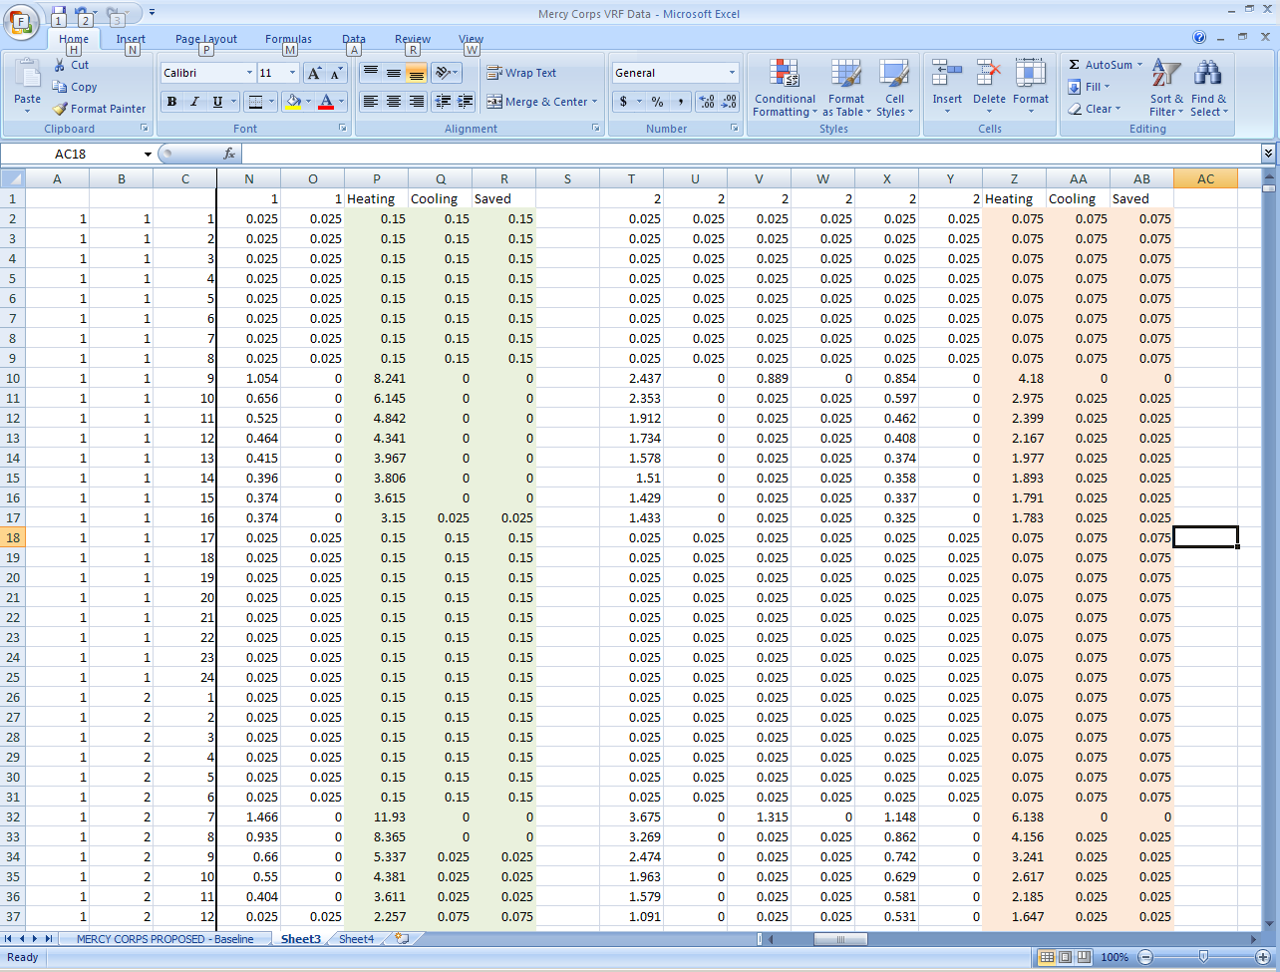
Figure 5 – VRF energy recovery spreadsheet screenshot

Appendix A—Energy Optimization

Table A-1 – Energy use and energy costs with no exceptional calculations

Table A-1 – Energy use and energy costs with exceptional calculation 1
Table A-2 – Summary of baseline end uses and peak loads, in utility units, by orientation

End Use | 0º | 90º | 180º | 270º | Average | No EC | EC 1
Lighting - Interior, kWh | 315,652 | 315,652 | 315,652 | 315,652 | 315,652 | 208,374 | 208,374
Peak, kW | 73.7 | 73.7 | 73.7 | 73.7 | 73.7 | 67.0 | 67.0
Misc Equipment, kWh | 361,964 | 361,964 | 361,964 | 361,964 | 361,964 | 361,964 | 361,964
Peak, kW | 79.9 | 79.9 | 79.9 | 79.9 | 79.9 | 79.9 | 79.9
Space Heating, therms | 28,462 | 29,348 | 28,906 | 27,645 | 28,590 | 2,845 | 2,845
Peak, MBH | 3,300.0 | 3,300.0 | 3,300.0 | 3,300.0 | 3,300.0 | 400.0 | 400.0
Space Heating, kWh | 0 | 0 | 0 | 0 | 0 | 10,363 | 10,363
Peak, kW | 0.0 | 0.0 | 0.0 | 0.0 | 0.0 | 73.7 | 73.7
Space Cooling, kWh | 110,967 | 111,314 | 108,175 | 109,268 | 109,931 | 107,991 | 107,991
Peak, kW | 201.0 | 200.5 | 201.8 | 194.5 | 199.5 | 119.5 | 119.5
Pumps & Aux, kWh | 10,953 | 11,159 | 10,541 | 9,776 | 10,607 | 13,323 | 13,323
Peak, kW | 2.8 | 2.9 | 2.8 | 2.7 | 2.8 | 4.5 | 4.5
Fans, kWh | 99,468 | 99,617 | 99,420 | 98,990 | 99,374 | 105,523 | 105,523
Peak, kW | 56.0 | 54.0 | 54.7 | 56.4 | 55.3 | 35.8 | 35.8
Ht Pump Supplem, kWh | 0 | 0 | 0 | 0 | 0 | 74 | 74
Peak, kW | 0.0 | 0.0 | 0.0 | 0.0 | 0.0 | 23.6 | 23.6
DHW, kWh | 39,854 | 39,854 | 39,854 | 39,854 | 39,854 | 39,814 | 39,814
Peak, kW | 16.0 | 16.0 | 16.0 | 16.0 | 16.0 | 16.0 | 16.0
Excep Calculation, kWh | 0 | 0 | 0 | 0 | 0 | 0 | (6,964)
Peak, kW | 0.0 | 0.0 | 0.0 | 0.0 | 0.0 | 0.0 | n/a
kWh | 938,859 | 939,562 | 935,607 | 935,505 | 937,383 | 847,425 | 840,461
therms | 28,462 | 29,348 | 28,906 | 27,645 | 28,590 | 2,845 | 2,845
Electrical Energy Cost | $72,710 | $72,684 | $72,549 | $72,247 | $72,548 | $61,848 | $61,340
Natural Gas Energy Cost | $33,132 | $34,034 | $33,582 | $32,293 | $33,260 | $6,844 | $6,844
Total Energy Cost | $105,842 | $106,718 | $106,131 | $104,540 | $105,808 | $68,692 | $68,184

Table A-3 – Summary of baseline end uses and peak loads, in kBtu/yr and MBH, by orientation

End Use | 0º | 90º | 180º | 270º | Average | No EC | EC 1
Lighting - Interior, kBtu | 1,077,300 | 1,077,300 | 1,077,300 | 1,077,300 | 1,077,300 | 711,200 | 711,200
Peak, MBH | 251.5 | 251.5 | 251.5 | 251.5 | 251.5 | 228.6 | 228.6
Misc Equipment, kBtu | 1,235,400 | 1,235,400 | 1,235,400 | 1,235,400 | 1,235,400 | 1,235,400 | 1,235,400
Peak, MBH | 272.6 | 272.6 | 272.6 | 272.6 | 272.6 | 272.6 | 272.6
Space Heating (gas), kBtu | 2,846,200 | 2,934,800 | 2,890,600 | 2,764,500 | 2,859,025 | 284,500 | 284,500
Peak, MBH | 3,300.0 | 3,300.0 | 3,300.0 | 3,300.0 | 3,300.0 | 400.0 | 400.0
Space Heating (elec), kBtu | 0 | 0 | 0 | 0 | 0 | 35,400 | 35,400
Peak, MBH | 0.0 | 0.0 | 0.0 | 0.0 | 0.0 | 251.5 | 251.5
Space Cooling, kBtu | 378,700 | 379,900 | 369,200 | 372,900 | 375,175 | 368,600 | 368,600
Peak, MBH | 685.8 | 684.1 | 688.6 | 663.7 | 680.5 | 407.7 | 407.7
Pumps & Aux, kBtu | 37,400 | 38,100 | 3,600 | 33,400 | 28,125 | 46 | 46
Peak, MBH | 9.6 | 9.9 | 9.6 | 9.2 | 9.6 | 15.4 | 15.4
Fans, kBtu | 339,500 | 340,000 | 339,300 | 337,800 | 339,150 | 360,100 | 360,100
Peak, MBH | 191.1 | 184.3 | 186.6 | 192.4 | 188.6 | 122.2 | 122.2
Ht Pump Supplem, kBtu | 0 | 0 | 0 | 0 | 0 | 300 | 300
Peak, MBH | 0.0 | 0.0 | 0.0 | 0.0 | 0.0 | 80.5 | 80.5
DHW, kBtu | 136,000 | 136,000 | 136,000 | 136,000 | 136,000 | 135,900 | 135,900
Peak, MBH | 54.6 | 54.6 | 54.6 | 54.6 | 54.6 | 16.0 | 16.0
Excep Calc, kBtu | 0 | 0 | 0 | 0 | 0 | 0 | (23,775)
Peak, MBH | 0.0 | 0.0 | 0.0 | 0.0 | 0.0 | 0.0 | 0.0
kBtu | 6,050,500 | 6,141,500 | 6,051,400 | 5,957,300 | 6,050,175 | 3,131,446 | 3,107,670

Appendix B-1.1—BEPS report, run for the Mercy Corps design model

Mercy Corps Proposed Design DOE-2.2-44e4 1/16/2009 10:34:19 BDL RUN 1

REPORT- BEPS Building Energy Performance WEATHER FILE- Portland OR TMY2
---------------------------------------------------------------------------------------------------------------------------------

TASK MISC SPACE SPACE HEAT PUMPS VENT REFRIG HT PUMP DOMEST EXT
LIGHTS LIGHTS EQUIP HEATING COOLING REJECT & AUX FANS DISPLAY SUPPLEM HOT WTR USAGE TOTAL
------- ------- ------- ------- ------- ------- ------- ------- ------- ------- ------- ------- --------

EM1 ELECTRICITY
MBTU 711.2 0.0 1235.4 35.4 368.6 0.0 45.5 360.1 0.0 0.3 135.9 0.0 2892.2

FM1 NATURAL-GAS
MBTU 0.0 0.0 0.0 284.5 0.0 0.0 0.0 0.0 0.0 0.0 0.0 0.0 284.5
======= ======= ======= ======= ======= ======= ======= ======= ======= ======= ======= ======= ========

MBTU 711.2 0.0 1235.4 319.9 368.6 0.0 45.5 360.1 0.0 0.3 135.9 0.0 3176.8

TOTAL SITE ENERGY 3176.75 MBTU 43.2 KBTU/SQFT-YR GROSS-AREA 43.2 KBTU/SQFT-YR NET-AREA
TOTAL SOURCE ENERGY 8961.23 MBTU 121.7 KBTU/SQFT-YR GROSS-AREA 121.7 KBTU/SQFT-YR NET-AREA

PERCENT OF HOURS ANY SYSTEM ZONE OUTSIDE OF THROTTLING RANGE = 0.0
PERCENT OF HOURS ANY PLANT LOAD NOT SATISFIED = 0.0

NOTE: ENERGY IS APPORTIONED HOURLY TO ALL END-USE CATEGORIES.

Appendix B-1.2—BEPU report, run for the Mercy Corps design model

Mercy Corps Proposed Design DOE-2.2-44e4 1/16/2009 10:34:19 BDL RUN 1

REPORT- BEPU Building Utility Performance WEATHER FILE- Portland OR TMY2
---------------------------------------------------------------------------------------------------------------------------------

TASK MISC SPACE SPACE HEAT PUMPS VENT REFRIG HT PUMP DOMEST EXT
LIGHTS LIGHTS EQUIP HEATING COOLING REJECT & AUX FANS DISPLAY SUPPLEM HOT WTR USAGE TOTAL
------- ------- ------- ------- ------- ------- ------- ------- ------- ------- ------- ------- --------

EM1 ELECTRICITY
KWH 208374. 0. 361964. 10363. 107991. 0. 13323. 105523. 0. 74. 39814. 0. 847425.

FM1 NATURAL-GAS
THERM 0. 0. 0. 2845. 0. 0. 0. 0. 0. 0. 0. 0. 2845.

TOTAL ELECTRICITY 847425. KWH 11.511 KWH /SQFT-YR GROSS-AREA 11.511 KWH /SQFT-YR NET-AREA
TOTAL NATURAL-GAS 2845. THERM 0.039 THERM /SQFT-YR GROSS-AREA 0.039 THERM /SQFT-YR NET-AREA

PERCENT OF HOURS ANY SYSTEM ZONE OUTSIDE OF THROTTLING RANGE = 0.0
PERCENT OF HOURS ANY PLANT LOAD NOT SATISFIED = 0.0

NOTE: ENERGY IS APPORTIONED HOURLY TO ALL END-USE CATEGORIES.

Appendix B-1.3—ES-D report, run for the MERCY CORPS design model

Mercy Corps Proposed Design DOE-2.2-44e4 1/16/2009 10:34:19 BDL RUN 1

REPORT- ES-D Energy Cost Summary WEATHER FILE- Portland OR TMY2
---------------------------------------------------------------------------------------------------------------------------------

METERED TOTAL VIRTUAL
ENERGY CHARGE RATE RATE USED
UTILITY-RATE RESOURCE METERS UNITS/YR ($) ($/UNIT) ALL YEAR?
-------------------------------- ---------------- ----------- ------------------- ---------- ---------- ---------

PGE 83-S 3P N-TOU Lrg N-Res Elec ELECTRICITY EM1 847425. KWH 61848. 0.0730 YES

NW Natural-OR 31-Comm-Vol NATURAL-GAS FM1 2845. THERM 6844. 2.4053 YES

==========
68691.

ENERGY COST/GROSS BLDG AREA: 0.93
ENERGY COST/NET BLDG AREA: 0.93

Appendix B-2.1—BEPS report, runs for the Mercy Corps baseline model

Mercy Corps Baseline 0-Degree Rotation DOE-2.2-44e4 1/15/2009 15:45:41 BDL RUN 1

REPORT- BEPS Building Energy Performance WEATHER FILE- Portland OR TMY2
---------------------------------------------------------------------------------------------------------------------------------

TASK MISC SPACE SPACE HEAT PUMPS VENT REFRIG HT PUMP DOMEST EXT
LIGHTS LIGHTS EQUIP HEATING COOLING REJECT & AUX FANS DISPLAY SUPPLEM HOT WTR USAGE TOTAL
------- ------- ------- ------- ------- ------- ------- ------- ------- ------- ------- ------- --------

EM1 ELECTRICITY
MBTU 1077.3 0.0 1235.4 0.0 378.7 0.0 37.4 339.5 0.0 0.0 136.0 0.0 3204.3

FM1 NATURAL-GAS
MBTU 0.0 0.0 0.0 2846.2 0.0 0.0 0.0 0.0 0.0 0.0 0.0 0.0 2846.2
======= ======= ======= ======= ======= ======= ======= ======= ======= ======= ======= ======= ========

MBTU 1077.3 0.0 1235.4 2846.2 378.7 0.0 37.4 339.5 0.0 0.0 136.0 0.0 6050.5

TOTAL SITE ENERGY 6050.46 MBTU 82.2 KBTU/SQFT-YR GROSS-AREA 82.2 KBTU/SQFT-YR NET-AREA
TOTAL SOURCE ENERGY 12459.06 MBTU 169.2 KBTU/SQFT-YR GROSS-AREA 169.2 KBTU/SQFT-YR NET-AREA

PERCENT OF HOURS ANY SYSTEM ZONE OUTSIDE OF THROTTLING RANGE = 0.4
PERCENT OF HOURS ANY PLANT LOAD NOT SATISFIED = 0.0

NOTE: ENERGY IS APPORTIONED HOURLY TO ALL END-USE CATEGORIES.

Mercy Corps Baseline 90-Degree Rotation DOE-2.2-44e4 1/15/2009 16:23:03 BDL RUN 1

REPORT- BEPS Building Energy Performance WEATHER FILE- Portland OR TMY2
---------------------------------------------------------------------------------------------------------------------------------

TASK MISC SPACE SPACE HEAT PUMPS VENT REFRIG HT PUMP DOMEST EXT
LIGHTS LIGHTS EQUIP HEATING COOLING REJECT & AUX FANS DISPLAY SUPPLEM HOT WTR USAGE TOTAL
------- ------- ------- ------- ------- ------- ------- ------- ------- ------- ------- ------- --------

EM1 ELECTRICITY
MBTU 1077.3 0.0 1235.4 0.0 379.9 0.0 38.1 340.0 0.0 0.0 136.0 0.0 3206.7

FM1 NATURAL-GAS
MBTU 0.0 0.0 0.0 2934.8 0.0 0.0 0.0 0.0 0.0 0.0 0.0 0.0 2934.8
======= ======= ======= ======= ======= ======= ======= ======= ======= ======= ======= ======= ========

MBTU 1077.3 0.0 1235.4 2934.8 379.9 0.0 38.1 340.0 0.0 0.0 136.0 0.0 6141.4

TOTAL SITE ENERGY 6141.45 MBTU 83.4 KBTU/SQFT-YR GROSS-AREA 83.4 KBTU/SQFT-YR NET-AREA
TOTAL SOURCE ENERGY 12554.85 MBTU 170.5 KBTU/SQFT-YR GROSS-AREA 170.5 KBTU/SQFT-YR NET-AREA

PERCENT OF HOURS ANY SYSTEM ZONE OUTSIDE OF THROTTLING RANGE = 0.5
PERCENT OF HOURS ANY PLANT LOAD NOT SATISFIED = 0.0

NOTE: ENERGY IS APPORTIONED HOURLY TO ALL END-USE CATEGORIES.

Mercy Corps Baseline 180-Degree Rotation DOE-2.2-44e4 51/15/2009 16:24:08 BDL RUN 1

REPORT- BEPS Building Energy Performance WEATHER FILE- Portland OR TMY2
---------------------------------------------------------------------------------------------------------------------------------

TASK MISC SPACE SPACE HEAT PUMPS VENT REFRIG HT PUMP DOMEST EXT
LIGHTS LIGHTS EQUIP HEATING COOLING REJECT & AUX FANS DISPLAY SUPPLEM HOT WTR USAGE TOTAL
------- ------- ------- ------- ------- ------- ------- ------- ------- ------- ------- ------- --------

EM1 ELECTRICITY
MBTU 1077.3 0.0 1235.4 0.0 369.2 0.0 36.0 339.3 0.0 0.0 136.0 0.0 3193.2

FM1 NATURAL-GAS
MBTU 0.0 0.0 0.0 2890.6 0.0 0.0 0.0 0.0 0.0 0.0 0.0 0.0 2890.6
======= ======= ======= ======= ======= ======= ======= ======= ======= ======= ======= ======= ========

MBTU 1077.3 0.0 1235.4 2890.6 369.2 0.0 36.0 339.3 0.0 0.0 136.0 0.0 6083.8

TOTAL SITE ENERGY 6083.81 MBTU 82.6 KBTU/SQFT-YR GROSS-AREA 82.6 KBTU/SQFT-YR NET-AREA
TOTAL SOURCE ENERGY 12470.21 MBTU 169.4 KBTU/SQFT-YR GROSS-AREA 169.4 KBTU/SQFT-YR NET-AREA

PERCENT OF HOURS ANY SYSTEM ZONE OUTSIDE OF THROTTLING RANGE = 0.4
PERCENT OF HOURS ANY PLANT LOAD NOT SATISFIED = 0.0

NOTE: ENERGY IS APPORTIONED HOURLY TO ALL END-USE CATEGORIES.

Mercy Corps Baseline 270-Degree Rotation DOE-2.2-44e4 1/15/2009 16:25:03 BDL RUN 1

REPORT- BEPS Building Energy Performance WEATHER FILE- Portland OR TMY2
---------------------------------------------------------------------------------------------------------------------------------

TASK MISC SPACE SPACE HEAT PUMPS VENT REFRIG HT PUMP DOMEST EXT
LIGHTS LIGHTS EQUIP HEATING COOLING REJECT & AUX FANS DISPLAY SUPPLEM HOT WTR USAGE TOTAL
------- ------- ------- ------- ------- ------- ------- ------- ------- ------- ------- ------- --------

EM1 ELECTRICITY
MBTU 1077.3 0.0 1235.4 0.0 372.9 0.0 33.4 337.8 0.0 0.0 136.0 0.0 3192.8

FM1 NATURAL-GAS
MBTU 0.0 0.0 0.0 2764.5 0.0 0.0 0.0 0.0 0.0 0.0 0.0 0.0 2764.5
======= ======= ======= ======= ======= ======= ======= ======= ======= ======= ======= ======= ========

MBTU 1077.3 0.0 1235.4 2764.5 372.9 0.0 33.4 337.8 0.0 0.0 136.0 0.0 5957.4

TOTAL SITE ENERGY 5957.39 MBTU 80.9 KBTU/SQFT-YR GROSS-AREA 80.9 KBTU/SQFT-YR NET-AREA
TOTAL SOURCE ENERGY 12343.10 MBTU 167.7 KBTU/SQFT-YR GROSS-AREA 167.7 KBTU/SQFT-YR NET-AREA

PERCENT OF HOURS ANY SYSTEM ZONE OUTSIDE OF THROTTLING RANGE = 0.4
PERCENT OF HOURS ANY PLANT LOAD NOT SATISFIED = 0.0

NOTE: ENERGY IS APPORTIONED HOURLY TO ALL END-USE CATEGORIES.

Appendix B-2.2—BEPU reports, runs for the MERCY CORPS baseline model

Mercy Corps Baseline 0-Degree Rotation DOE-2.2-44e4 1/15/2009 15:45:41 BDL RUN 1

REPORT- BEPU Building Utility Performance WEATHER FILE- Portland OR TMY2
---------------------------------------------------------------------------------------------------------------------------------

TASK MISC SPACE SPACE HEAT PUMPS VENT REFRIG HT PUMP DOMEST EXT
LIGHTS LIGHTS EQUIP HEATING COOLING REJECT & AUX FANS DISPLAY SUPPLEM HOT WTR USAGE TOTAL
------- ------- ------- ------- ------- ------- ------- ------- ------- ------- ------- ------- --------

EM1 ELECTRICITY
KWH 315652. 0. 361964. 0. 110967. 0. 10953. 99468. 0. 0. 39854. 0. 938859.

FM1 NATURAL-GAS
THERM 0. 0. 0. 28462. 0. 0. 0. 0. 0. 0. 0. 0. 28462.

TOTAL ELECTRICITY 938859. KWH 12.753 KWH /SQFT-YR GROSS-AREA 12.753 KWH /SQFT-YR NET-AREA
TOTAL NATURAL-GAS 28462. THERM 0.387 THERM /SQFT-YR GROSS-AREA 0.387 THERM /SQFT-YR NET-AREA

PERCENT OF HOURS ANY SYSTEM ZONE OUTSIDE OF THROTTLING RANGE = 0.4
PERCENT OF HOURS ANY PLANT LOAD NOT SATISFIED = 0.0

NOTE: ENERGY IS APPORTIONED HOURLY TO ALL END-USE CATEGORIES.

Mercy Corps Baseline 90-Degree Rotation DOE-2.2-44e4 1/15/2009 15:45:41 16:23:03 BDL RUN 1

REPORT- BEPU Building Utility Performance WEATHER FILE- Portland OR TMY2
---------------------------------------------------------------------------------------------------------------------------------

TASK MISC SPACE SPACE HEAT PUMPS VENT REFRIG HT PUMP DOMEST EXT
LIGHTS LIGHTS EQUIP HEATING COOLING REJECT & AUX FANS DISPLAY SUPPLEM HOT WTR USAGE TOTAL
------- ------- ------- ------- ------- ------- ------- ------- ------- ------- ------- ------- --------

EM1 ELECTRICITY
KWH 315652. 0. 361964. 0. 111314. 0. 11159. 99617. 0. 0. 39854. 0. 939562.

FM1 NATURAL-GAS
THERM 0. 0. 0. 29348. 0. 0. 0. 0. 0. 0. 0. 0. 29348.

TOTAL ELECTRICITY 939562. KWH 12.763 KWH /SQFT-YR GROSS-AREA 12.763 KWH /SQFT-YR NET-AREA
TOTAL NATURAL-GAS 29348. THERM 0.399 THERM /SQFT-YR GROSS-AREA 0.399 THERM /SQFT-YR NET-AREA

PERCENT OF HOURS ANY SYSTEM ZONE OUTSIDE OF THROTTLING RANGE = 0.5
PERCENT OF HOURS ANY PLANT LOAD NOT SATISFIED = 0.0

NOTE: ENERGY IS APPORTIONED HOURLY TO ALL END-USE CATEGORIES.

Mercy Corps Baseline 180-Degree Rotation DOE-2.2-44e4 1/15/2009 16:24:08 BDL RUN 1

REPORT- BEPU Building Utility Performance WEATHER FILE- Portland OR TMY2
---------------------------------------------------------------------------------------------------------------------------------

TASK MISC SPACE SPACE HEAT PUMPS VENT REFRIG HT PUMP DOMEST EXT
LIGHTS LIGHTS EQUIP HEATING COOLING REJECT & AUX FANS DISPLAY SUPPLEM HOT WTR USAGE TOTAL
------- ------- ------- ------- ------- ------- ------- ------- ------- ------- ------- ------- --------

EM1 ELECTRICITY
KWH 315652. 0. 361964. 0. 108175. 0. 10541. 99420. 0. 0. 39854. 0. 935607.

FM1 NATURAL-GAS
THERM 0. 0. 0. 28906. 0. 0. 0. 0. 0. 0. 0. 0. 28906.

TOTAL ELECTRICITY 935607. KWH 12.709 KWH /SQFT-YR GROSS-AREA 12.709 KWH /SQFT-YR NET-AREA
TOTAL NATURAL-GAS 28906. THERM 0.393 THERM /SQFT-YR GROSS-AREA 0.393 THERM /SQFT-YR NET-AREA

PERCENT OF HOURS ANY SYSTEM ZONE OUTSIDE OF THROTTLING RANGE = 0.4
PERCENT OF HOURS ANY PLANT LOAD NOT SATISFIED = 0.0

NOTE: ENERGY IS APPORTIONED HOURLY TO ALL END-USE CATEGORIES.

Mercy Corps Baseline 270-Degree Rotation DOE-2.2-44e4 1/15/2009 16:25:03 BDL RUN 1

REPORT- BEPU Building Utility Performance WEATHER FILE- Portland OR TMY2
---------------------------------------------------------------------------------------------------------------------------------

TASK MISC SPACE SPACE HEAT PUMPS VENT REFRIG HT PUMP DOMEST EXT
LIGHTS LIGHTS EQUIP HEATING COOLING REJECT & AUX FANS DISPLAY SUPPLEM HOT WTR USAGE TOTAL
------- ------- ------- ------- ------- ------- ------- ------- ------- ------- ------- ------- --------

EM1 ELECTRICITY
KWH 315652. 0. 361964. 0. 109268. 0. 9776. 98990. 0. 0. 39854. 0. 935505.

FM1 NATURAL-GAS
THERM 0. 0. 0. 27645. 0. 0. 0. 0. 0. 0. 0. 0. 27645.

TOTAL ELECTRICITY 935505. KWH 12.707 KWH /SQFT-YR GROSS-AREA 12.707 KWH /SQFT-YR NET-AREA
TOTAL NATURAL-GAS 27645. THERM 0.376 THERM /SQFT-YR GROSS-AREA 0.376 THERM /SQFT-YR NET-AREA

PERCENT OF HOURS ANY SYSTEM ZONE OUTSIDE OF THROTTLING RANGE = 0.4
PERCENT OF HOURS ANY PLANT LOAD NOT SATISFIED = 0.0

NOTE: ENERGY IS APPORTIONED HOURLY TO ALL END-USE CATEGORIES.

Appendix B-2.3—ES-D reports, runs for the MERCY CORPS baseline model
Mercy Corps Baseline 0-Degree Rotation DOE-2.2-44e4 1/15/2009 15:45:41 BDL RUN 1

REPORT- ES-D Energy Cost Summary WEATHER FILE- Portland OR TMY2
---------------------------------------------------------------------------------------------------------------------------------

METERED TOTAL VIRTUAL
ENERGY CHARGE RATE RATE USED
UTILITY-RATE RESOURCE METERS UNITS/YR ($) ($/UNIT) ALL YEAR?
-------------------------------- ---------------- ----------- ------------------- ---------- ---------- ---------

PGE 83-S 3P N-TOU Lrg N-Res Elec ELECTRICITY EM1 938859. KWH 72710. 0.0774 YES

NW Natural-OR 31-Comm-Vol NATURAL-GAS FM1 28462. THERM 33132. 1.1641 YES

==========
105842.

ENERGY COST/GROSS BLDG AREA: 1.44
ENERGY COST/NET BLDG AREA: 1.44

Mercy Corps Baseline 90-Degree Rotation DOE-2.2-44e4 51/15/2009 16:23:03 BDL RUN 1

REPORT- ES-D Energy Cost Summary WEATHER FILE- Portland OR TMY2
---------------------------------------------------------------------------------------------------------------------------------

METERED TOTAL VIRTUAL
ENERGY CHARGE RATE RATE USED
UTILITY-RATE RESOURCE METERS UNITS/YR ($) ($/UNIT) ALL YEAR?
-------------------------------- ---------------- ----------- ------------------- ---------- ---------- ---------

PGE 83-S 3P N-TOU Lrg N-Res Elec ELECTRICITY EM1 939562. KWH 72684. 0.0774 YES

NW Natural-OR 31-Comm-Vol NATURAL-GAS FM1 29348. THERM 34034. 1.1597 YES

==========
106718.

ENERGY COST/GROSS BLDG AREA: 1.45
ENERGY COST/NET BLDG AREA: 1.45

Mercy Corps Baseline 180-Degree Rotation DOE-2.2-44e4 1/15/2009 16:24:08 BDL RUN 1

REPORT- ES-D Energy Cost Summary WEATHER FILE- Portland OR TMY2
---------------------------------------------------------------------------------------------------------------------------------

METERED TOTAL VIRTUAL
ENERGY CHARGE RATE RATE USED
UTILITY-RATE RESOURCE METERS UNITS/YR ($) ($/UNIT) ALL YEAR?
-------------------------------- ---------------- ----------- ------------------- ---------- ---------- ---------

PGE 83-S 3P N-TOU Lrg N-Res Elec ELECTRICITY EM1 935607. KWH 72549. 0.0775 YES

NW Natural-OR 31-Comm-Vol NATURAL-GAS FM1 28906. THERM 33582. 1.1618 YES

==========
106131.

ENERGY COST/GROSS BLDG AREA: 1.44
ENERGY COST/NET BLDG AREA: 1.44

Mercy Corps Baseline 270-Degree Rotation DOE-2.2-44e4 1/15/2009 16:25:03 BDL RUN 1

REPORT- ES-D Energy Cost Summary WEATHER FILE- Portland OR TMY2
---------------------------------------------------------------------------------------------------------------------------------

METERED TOTAL VIRTUAL
ENERGY CHARGE RATE RATE USED
UTILITY-RATE RESOURCE METERS UNITS/YR ($) ($/UNIT) ALL YEAR?
-------------------------------- ---------------- ----------- ------------------- ---------- ---------- ---------

PGE 83-S 3P N-TOU Lrg N-Res Elec ELECTRICITY EM1 935505. KWH 72247. 0.0772 YES

NW Natural-OR 31-Comm-Vol NATURAL-GAS FM1 27645. THERM 32293. 1.1681 YES

==========
104540.

ENERGY COST/GROSS BLDG AREA: 1.42
ENERGY COST/NET BLDG AREA: 1.42

